UR Student Newsletter
Volume 3, December 2018

Moving Forward
The last six months have brought us closer to making UR Student a reality for the campus community. After an intensive work effort to get UR Student configured and ready for testing with converted data from the legacy Student Information System (SIS), we have held events to keep you informed and engaged. From the campus-wide Community Forum with hands-on attendee experiences and a Programs of Study (POS) remote Demo Day in November to a December remote demonstration of Courses in UR Student, we're moving towards getting the new system ready for your feedback to make it even better for rollout in July 2019.


UR Student Forum Draws Crowd & Excitement!

From Records and Registration to Advising and Student Finance, many attendees got to navigate through UR Student with expert guidance. Between getting to perform system tasks or strike up conversations with the Project’s leadership, those at event got a little more familiar with the nuts and bolts of UR Student.
Some participants who had a personalized hands-on session also volunteered to help us test the system. We really appreciate this kind of involvement to get valuable feedback from those who will be the system’s everyday users.
Even if you couldn’t make it to the event, take a look at the UR Student Community Forum PowerPoint presentation on our Demo Days page, or just ask any questions about what we covered.
UR Student's November Community Forum featured a hands-on experience for attendees who signed up.
Learn More:
Register now for the December 20th UR Student Remote Demo Days on Changes in Courses & Course Sections
Watch the November 14th Remote Demo Days playback on Programs of Study; changes coming are listed below.

Programs of Study Redefined
There will be some powerful changes in the new system that includes the following:
- New Terminology
- Program of Study Code and Structure
- Program of Study Type

Our Project Team has been listening to feedback from around the University to make the POS naming structure and functions reflect our needs at this time.
New Terminology:
Program of Study: Program of study represents the educational objectives offered at a University. For example, a Biology Major through which a student can achieve a Bachelor of Science Degree. Programs of Study also govern the academic requirements for students; academic policies that apply to students; and the educational credentials students can earn.
Matriculation: The process of moving students from Applicant to Student stage that creates the academic record for the student. Note: Students can have multiple academic records, each associated with one or more Programs of Study that support a distinct educational objective.
Academic Units (AUs): This refers to schools, colleges and departments designed within the UR Student system.
To give you an idea of how they will function, those with the appropriate security can use AUs to:
- Assign faculty to teach a course section
- Facilitate a system workflow and assignment of duties
- Run reports by any AU (e.g. report enrollment by school, by team, and by course)
AUs can specify which units can do the following in UR Student:
- Administer financial aid
- Offer courses and programs of study
- Admit students
- Allow students to know all the schools they belong to at a glance
Program of Study Code and Structure:
After identifying a consistent set of criteria, we arrived at an intuitive code convention for any student POS. The logical progression behind creating codes in UR Student depends on the school, degree, whether the major is declared or not, and the original SIS code (see examples here).

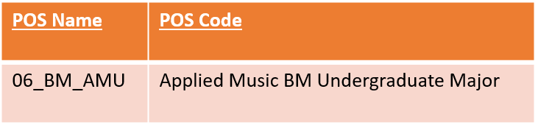
New POS naming convention for declared major
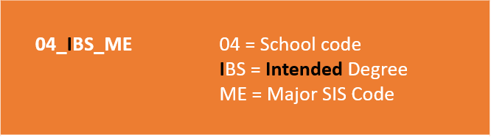
New POS naming convention for undeclared major ("I" designates "intended")
Program of Study Type:
With Program Types, such as Certificates, Majors, or Non-Credit, administrators can configure POS to stand alone, grant credentials or even have concentrations, as shown below. There are significant additional options (for registrars):
- Fast-pass admissions allows students in through the Admissions system and into a POS
- “Program complete” (i.e. designates graduation)
Watch Now: Program Type Demo
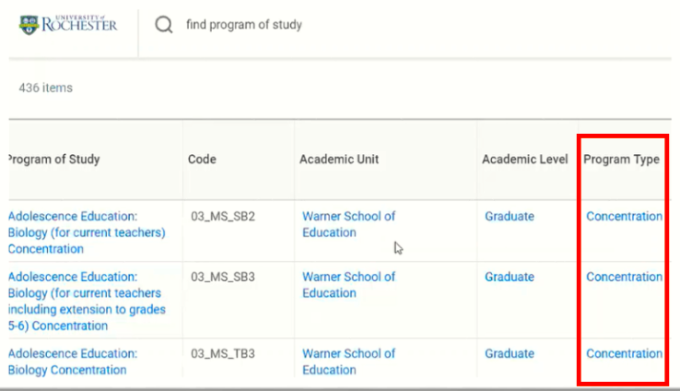
Example of Program Type in UR Student along with AU, AL and POS
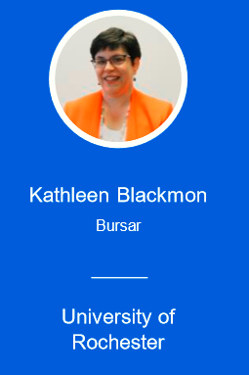
UR Student Spotlight: University Bursar Kathy Blackmon
We caught up with University of Rochester Bursar Kathy Blackmon after she took part in a panel discussion at a Workday user conference in early November. During Kathy’s session, “Workday Student Financials: From Concept to Reality,” she delved into our collaboration on the new system’s design and deployment. Kathy shared some of her experiences and lessons learned on our journey towards University-wide system transformation.
Read the full article
Subscribe to Stay in Touch with UR Student!
Learn more about anticipated changes to the University’s functional areas by keeping up with SIG meetings and other news. Go to UR Student News now to subscribe to our web updates to stay in the know.

